Winning Tradeoffs in Space and Time for Environmentally Responsible Offshore Wind Energy Development

Benjamin D. Best[[1]](#footnote-1), Patrick N. Halpin[[2]](#footnote-2)

# Abstract

Although offshore wind energy development (OWED) offers a much-needed renewable energy alternative to fossil fuels, holistic and effective methods for evaluating environmental impacts on wildlife in both space and time have been lacking. The lengthy environmental compliance process, estimated to incur 7 – 10 year permitting timeline, has been identified as a significant impediment to offshore energy development in US waters. To responsibly and expeditiously evaluate environmental impacts we differentially assess sensitivity of wildlife above the water line in space, and below the water line in time. During long-term operation, birds can collide and be displaced by active turbines. During episodic pre-operation phases, cetaceans are most heavily impacted acoustically by seismic air gun surveys and pile driving. We have developed a novel spatio-temporal decision support framework that interactively visualizes tradeoffs between OWED industry profits and wildlife sensitivities, in both space and time. The framework highlights sites that are the most profitable and least sensitive to birds. For a given site, pre-operation activities are advised by cetacean sensitivity across months of the year that minimize impacts on migratory cetaceans, particularly those of highest conservation concern such as the North Atlantic right whale (*Eubalaena Glacialis*) in the case of our study area, the US Mid-Atlantic. Other taxa are certainly affected by OWED and should be incorporated into this framework, but data on their distributions and/or sensitivities is currently less well known. Built with open-source software made publicly available, the authors hope this framework will be extended even more comprehensively into the future as our knowledge on species distributions and OWED sensitivities expands.

# Introduction

As of the first half of 2015, the total installed capacity is at 8,990 megawatts (MW) worldwide with the United Kingdom leading and Germany following at 4,625 MW and 1,505 MW respectively (Smith et al. 2015). Europe accounts for 96% of installed capacity with the remainder in Asia. The United States is noticeably absent from any currently installed offshore wind capacity, despite high wind availability and coastal energy demand. The first grid connected US wind farm did begin offshore construction July 2015 at Block Island, RI by Deepwater Wind and is anticipated to be in production at 30 MW fall 2016. Although other projects are slated for the future pipeline, what accounts for this stark lack of development in US waters?

The lengthy environmental compliance process, estimated to incur a 7 – 10 year permitting timeline, has been identified as a significant impediment to offshore energy development in US waters (Beaudry-Losique et al. 2011). A “Smart from the Start” interagency program led by the federal leasing agency, the Bureau of Ocean Energy Management (BOEM), has formed task forces to reduce these demands by identifying environmentally responsible Wind Energy Areas (WEAs) for offshore wind development (Smith et al. 2015). These areas, however, were the result of many negotiations between a wide variety of stakeholders and is not the result of a systematic quantitative process.

Renewable energy development has seen more success on land in the US, which reached 47 gigawatts (GW) of installed wind power generation by 2011 (Bolinger 2013) and 2.5 GW of solar by 2010 (Price 2010). Lessons on land may translate to improving the efficiency of marine spatial planning (Gopnik 2013). For instance, multi-criteria decision analysis (Stoms et al. 2013) enabled the Bureau of Land Management (BLM) to fast track certain areas for permitting as part of its Desert Renewable Energy Conservation Plan (DRECP) in the Southwest which were deemed likely to have the least impact on wildlife while providing sufficient wind or solar energy and nearby transmission capabilities to be profitable for development. Almost no human development is without some environmental impact, which are often difficult to quantify. Still, providing this high level view can flag potential conflict areas where greater caution should be exercised and conversely expedite permitting of other areas, for instance where species of concern are less likely to occur.

The regulatory landscape for environmental compliance and offshore wind permitting in the United States is quite vast requiring interagency oversight across a broad sweep of regulations (Beaudry-Losique et al. 2011), including: the National Environmental Policy Act (NEPA); Endangered Species Act (ESA); Marine Mammal Protection Act (MMPA); Magnuson-Stevens Fishery Conservation and Management Act; Marine Protection, Research, and Sanctuaries Act; National Marine Sanctuaries Act; Coastal Zone Management Act; National Historic Preservation Act; Federal Aviation Act; Federal Power Act; Ports and Waterways Safety Act; Rivers and Harbors Act; Outer Continental Lands; Clean Water Act; and Clean Air Act.

To make necessary information available to developers BOEM has also been facilitating the input of relevant spatial data into the online MarineCadastre.gov portal. Datasets detail individual species distributions and potential conflicts with other industries, such as military and transportation. While the availability of these datasets will no doubt aid the planning process for OWED, a comprehensive summary view of overall risk to wildlife is still lacking.

The contrasting tradeoffs between wildlife conservation and energy development can be explicitly modeled in terms of an efficiency frontier (White et al. 2012). Originally developed as portfolio analysis to weigh financial investment in terms of risk versus return over time (Markowitz 1952), tradeoff analysis provides a useful synoptic view for evaluating across many sites the risk to wildlife versus the profitable return to industry. Ideally, alternative sites can be chosen which maintain profitability while also maximizing conservation benefit. Plotting the value of each site along two axes (i.e. profitability versus conservation) readily yields a relationship, which for the ideal scenario of interacting services is concave (Lester et al. 2013).

Although White et al. (2012) explicitly mapped and plotted tradeoffs between whale watching conservation versus wind energy profitability, each scenario was an alternate wind farm configuration. The study was fine in spatial scale, so was not framed so as to offer spatial preference of one site versus another. Winiarski et al. (2014) did offer irreplaceability by site using a Marxan spatial prioritization software from density surface models of birds, but did not account explicitly for sensitivity of birds to OWED.

A holistic framework for quantifying sensitivity of birds to OWED was first developed by Garthe & Hüppop (2004) to account for species-specific responses to OWED according to direct (collision) and indirect (displacement) effects. This framework has been expanded upon (Furness et al. 2013) and explicitly mapped from density surface models in the UK by sensitivity to collision and displacement (Bradbury et al. 2014).

But how then are other species incorporated to the decision-making process? Goodale & Milman (2016) summarize impacts on wildlife in terms of a hazard-vulnerability-exposure model. OWED hazards are considered in terms of: 1) hazard intensity and phases of development (pre-construction, construction, operation, and decommissioning); vulnerability of species; and exposure in terms of space and time; all to be considered cumulatively. Impacts can be both direct, i.e. cause mortality, and indirect, i.e. influence individual behavior so as to reduce reproductive success. Direct impacts of birds and bats colliding with turbines have been reasonably well characterized while indirect effects of acoustic disturbance to marine mammals during pile driving has been difficult to quantify (Bailey et al. 2014).

The majority of direct OWED impacts to cetaceans are acoustic, not during operation but during pre-construction seismic surveys and pile driving during construction (Bailey et al. 2014, Firestone et al. 2015). Both of these activities impart a large amount of acoustic energy, which can kill or harm animals in the immediate vicinity (Damian & Merck 2014).

In contrast to Europe where seabirds are highly migratory and marine mammals are mostly resident, the US North Atlantic seaboard has fewer migratory seabirds and more migratory marine mammals. Effects on birds generally occur during the long-term operation of wind turbines, whereas impacts on marine mammals are most experienced episodically and acoustically during seismic surveying and pile driving. The varying nature of impacts in space and time leads us to conclude that sites should be selected in space to minimize long-term impacts on birds, and timing of surveying and construction activities to be conducted in times of the year when sensitive migratory marine mammals are least present. The goal of this study is to describe an interactive decision support framework that explores the economic and environmental tradeoffs in space and time to find optimal sites that minimize impact to wildlife while preserving profitability to OWED, using the US Mid-Atlantic as a case study area.

# Methods

## Study Area: Mid-Atlantic Coast of the US

The Mid-Atlantic continental shelf presents an opportune area for OWED given its strong offshore winds and proximity to densely populated coastal areas. The Atlantic Wind Connection, a Google backed offshore transmission grid in its early planning phase, could significantly lower costs to OWED leasees. Species densities are newly available for cetaceans (Roberts et al. 2016) and bird density surfaces (Atlantic Offshore Seabird Dataset Catalog) are available now and due to be updated shortly (Kinlan et al, *in prep*). The study area is defined by the available bird density surfaces (Figure 1).

## Wind Energy Valuation

The net present value (NPV) for each 10km pixel site was estimated using the Offshore Wind Energy Production model from the InVEST Toolbox version 3.2 (Guerry et al. 2012, Sharp et al. 2015). The candidate wind farm consists of 80 x 5MW turbines (400 MW capacity farm) with a hub height at 90m over a lifetime of 20 years. The NPV for a wind farm in the given pixel is determined by the gross revenues from wind energy (*Rt*) minus the costs (C*t*) annualized (*t*) over the lifetime (*T*) of the wind farm modified by the discount rate (*i*) or weighted average cost of capital ( 1 ). A discount rate of 5% was applied per White et al. (White et al. 2012).

|  |  |  |
| --- | --- | --- |
|  | $$NPV= \sum_{t=1}^{T}{\left(R_{t}-C_{t}\right){\left(1+i\right)}^{-t}}$$ | ( 1 ) |

In terms of siting, revenue is largely determined by wind speed at hub height and costs by transmission distance to the grid. Since grid connection points are not made publicly available, distance to shoreline serves as a proxy. An additional 4km to connect from shore to the grid was applied for all sites. An alternate scenario considering access to the Atlantic Wind Connection transmission reduced this distance to shore, but did not consider additional (as yet unknown) leasing costs for its use.

Parameter coefficients (*β*0,1) to model transmission cost (*TransCost*) based on megawatt size of the wind farm (*MW*) and total cable laid (*TotCable*) were estimated by fitting costs available via literature search by the InVEST team ( 2 ).

|  |  |  |
| --- | --- | --- |
|  | $$TransCost= β_{0}MW+β_{1}TotCable$$ | ( 2 ) |

Separate coefficients were modeled based on an assumption of switching from AC to DC at 60km or greater distance (Table 5).

Gross revenues (*R*) are derived from wind power by multiplying the price per kWh with the annual amount of kWh produced by the wind farm (*E*). This wind production is based on the individual turbine output (*O*) multiplied by the number of turbines (n=80). Individual turbine output is based on the default InVEST parameters for the 5 MW turbine configuration (cut-in at 3 ms-1; rated windspeed at 12.5 ms-1; cut-out at 30 ms-1; rotor diameter of 116m) to describe a polynomial of power (5 MW) over a range of wind speed (cut-in to cut-out). Wind speed is estimated at hub height from the reference surface using a power curve based on a fitted Weibull distribution[[3]](#footnote-3). Wind speed at the ocean surface reference height is provided by InVEST.

Depth is known to increase the cost of foundations and installation due to more required material, but is not explicitly modeled here due to lack of published data for establishing an explicit relationship. A $2 M installation cost per turbine is applied to all sites equally. The jacketed foundations generally required for a 5 MW turbine are more expensive than the less robust monopole foundations used for 3.6 MW turbines. Floating structures open the possibility of going to still greater depths, but are still in the demonstration phase.

Although the majority of costs are for installation, operations and maintenance account for a fraction of the capital expenditure annually. The default 3.5% value was applied.

## Bird Distribution and Sensitivity Score

Density distributions for 27 individual bird species were downloaded from the Avian Average Annual Abundances (O’Connell et al. 2011, Kinlan et al. 2012) available at MarineCadastre.gov. These density maps were matched with species having sensitivity to OWED from a recent UK-based study on bird sensitivity to OWED (Bradbury et al. 2014) to yield 21 species for analysis (Table 1). The 6 species having density distributions and missing a sensitivity value from Bradbury et al. (2014) were dropped from the analysis, but are all of Least Concern to extinction risk according to the IUCN RedList: Bonaparte's gull (*Chroicocephalus Philadelphia*), double-crested cormorant (*Phalacrocorax auritus*), laughing gull (*Larus atricilla*), red phalarope (*Phalaropus fulicarius*), and ring-billed gull (*Larus delawarensis*), surf scoter (*Melanitta perspicillata*).

Bird density maps are based scientific surveys in the U.S. Atlantic compiled since 1978 into The Compendium of Avian Information in the U.S. Atlantic Outer Continental Shelf (O’Connell et al. 2011). Density (individuals per 2.5 nm strip width) were calculated seasonally and then averaged across the year. This study (Kinlan et al. 2012) was performed by NOAA/NOS/NCCOS working with the USGS Patuxent Wildlife Research Center for BOEM.

Bird sensitivity to OWED developed by Bradbury et al. (2014) separated collision risk from displacement impacts similar to Furness et al. (2013), compared to the original species sensitivity Index (SSI) framework of Garthe & Hüppop (2004).

|  |  |  |
| --- | --- | --- |
|  | $$collision risk score=a*(m+t+n)/3$$ | ( 3 ) |

Terms contributing to collision risk are flight altitude (*a*), flight maneuverability (*m*), percentage of time flying (*t*), and nocturnal flight activity (*n*).

|  |  |  |
| --- | --- | --- |
|  | $$displacement score=[\left(d*h\right)*c]/10$$ | ( 4 ) |

Displacement score is determined by disturbance by wind farm structures, ship and helicopter traffic (*d*), habitat specialization (*h*) and conservation importance (*c*). Most terms are based on taxonomic expertise. The conservation importance score was based on UK-based measures: Birds Directive status, percent biogeographic population in English waters, adult survival rate and UK threat status.

The maximum of either collision risk or displacement score per species was used to arrive at the Atlantic study weights (Table 1).

|  |  |  |
| --- | --- | --- |
|  | $$bird sensitivity =max⁡( collision risk score, displacement score)$$ | ( 5 ) |

Per 10 km pixel, the average bird density was log-transformed, multiplied by bird sensitivity, and averaged across all species (*S*) (Figure 4).

|  |  |  |
| --- | --- | --- |
|  | $$bird pixel score={\sum_{bird}^{B}{\log\left({density}_{bird}+1\right)*{ sensitivity}_{bird}}}/B$$ | ( 6 ) |

## Cetacean Distribution and Conservation Status

Cetacean distributions were gathered from a recently published study (Roberts et al. 2016) describing density of cetaceans for 26 species and 3 guilds in the U.S. Atlantic using survey data from boats and planes over a 23 year period with a variety of habitat predictors, including depth, temperature, wind, eddies, and productivity.

Impacts to cetaceans from OWED are not well described, but understood to be mostly from intense acoustic energy during the installation phase from pile driving or during the pre-installation phase from seismic surveying (Bailey 2012, Bailey et al. 2014). The species-specific responses of cetaceans are known for very few marine mammals, and have only been modeled in spatially explicitly detail for the harbor seal (Thompson et al. 2013, Hastie et al. 2015). In the absence of a sensitivity index to OWED akin to the birds, conservation status was used as the sole measure of sensitivity to OWED. The NatureServe conservation status (Faber-Langendoen et al. 2009) was preferred because of greater specificity to the study area, versus many species listed as Data Deficient for the global IUCN RedList (Table 3). The scores were scaled 1 to 100 (Table 2) and applied to species, with averages taken for 3 guilds.

Unlike the bird distribution data, the cetacean predictions are available at monthly time steps. Cells containing the lowest 1% of total density were masked from analysis. Per species, densities (*d*) per 10 km2 pixel (*i*) were rescaled as the difference from mean value ($\overline{d}$) over the standard deviation of the density within the study area. Species scores were averaged across all species (*S*) to arrive at a cetacean score per pixel and month.

|  |  |  |
| --- | --- | --- |
|  | $${cetacean score}_{i}={\sum_{s}^{S}{\frac{d_{s,i}-\overline{d}}{sd\left(d\right)}*c_{s}}}/S$$ | ( 7 ) |

The cetacean score was finally rescaled 0 to 1, minimum to maximum.

## Evaluating Tradeoffs as a Utility Function

Deciding to site offshore wind energy development is based on weighing tradeoffs between wind energy profitability and species conservation. Each site can be examined according to a tradeoff plot with either value on the axis. Deciding how much influence species conservation will be imposed at the loss of wind profitability is a societal decision involving industry, government regulatory agencies and other stakeholders. Ideally, solutions exist which favor both goals, the preferred “win-win” scenario. We can quantitatively evaluate this tradeoff over a range of utility functions given by equation ( 8 ).

|  |  |  |
| --- | --- | --- |
|  | $$u= a*WindProfitability-\left(1-a\right)*BirdSensitivity$$ | ( 8 ) |

The weighting term ($a$) then indicates a preference of wind profitability versus bird sensitivity. Eventually this term could be implemented as sliders in the user interface. For the purposes of these initial results, we simulated over a naïve range of the weighting term ($a$) from 0 to 1 at a step of 0.1. The utility ($u$) was then averaged to arrive at an average utility ($\overline{u}$) per site.

So then what is a reasonable range of each axis and overall utility to suggest for OWED? Garthe & Hüppop (2004) designated the top 60% of bird sensitivity scores as areas of “concern” and top 20% as areas of “major concern”. We adopted these quantiles across each axes and overall utility.

Since the values of each axes (wind profitability and bird sensitivity) were normalized (0 to 1), it is worth pointing out that the relationship between these terms is dependent on the extent of the study area and the values contained therein.

## Spatio-Temporal Decision Support System

All the analysis, besides the wind energy valuation with InVEST, was coded in the free, open-source, cross-platform statistical programming language R (R Core Team 2015). The spatial-temporal decision support system web-based interface was developed with the R package Shiny (Chang et al. 2016) using leaflet (Cheng & Xie 2015) for interactive mapping and ggvis (Chang & Wickham 2015) with plotly (Sievert et al. 2016) for interactive plotting. The code is freely available on Github (Best 2016).

# Results

## Map of Wind Energy Valuation

The net present value of OWED for the U.S. Mid-Atlantic (Figure 2) shows a trend of increasing value offshore and more northern latitudes, which is largely a function of wind speed. Most coastal pixels near New Jersey and Delaware are even negative, thus unrealistic for investment. This pattern is consistent when modeling with the Atlantic Wind Connection (Figure 3) with higher profit to be gained nearby and further offshore.

## Map of Bird Sensitivity Score

Bird sensitivity exhibits a strong latitidunal gradient with Massachussets to the north having the highest values and lowest offshore from North Carolina (Figure 4).

## Map of Cetacean Conservation Status

Migration patterns of cetaceans in the U.S. Mid-Atlantic cause considerable variation between months (Figure 5). March is most intensely concentrated near the Gulf of Maine, May on the northern fringe, August diffuse throughout, and November peaked on either end of the study area with a consistent offshore signature. These patterns are largely driven by the North Atlantic right whale, which is critically imperiled and migrates south in the winter to calving grounds in Florida and north to forage in the summer in the Gulf of Maine, with some populations maintaining residency in Gulf of Maine year-round (Roberts et al. 2016).

## Tradeoffs in Space with Birds

By plotting individual pixel values per management objective, OWED profitability versus bird sensitivity, the tradeoff plot highlights sites that most match each objective (Figure 6). The upper right quadrant is most desirable for selecting the most profitable, least sensitive sites. This is further quantified by creating quadrants from quantile values along each axis, per the 20% and 60% quantiles introduced by Garthe & Hüppop (2004).

With the average utility value combining both objectives, these values are then plotted back onto the map to highlight areas of greatest prospective interest (Figure 7). Contouring the top 20% of sites reveals 6 hotspots for OWED. By labeling the highest value pixels within each of these hotspot areas, the pixel values can be compared with others and ranked (Table 4).

## Tradeoffs in Time with Cetaceans

Once sites are selected in space based on maximizing long-term operational profitability of OWED and minimizing impacts on sensitive bird species, impacts to cetaceans can be evaluated over time. Sites selected previously based on highest overall utility (Figure 7) are next examined over time to identify months with the least impact on cetaceans to conduct pre-operational activities such as pile driving and seismic surveying (Figure 8).

## Spatio-Temporal Decision Support System

The spatio-temporal decision support system (Figure 9) is highly interactive: pan and zoom in the map, click on tradeoff plot to highlight a site pixel on the map. Other criteria, such as military and shipping uses, besides those modeled are inevitably part of the planning process. This SDSS is not comprehensive in that way, but enables exploration of alternative sites to deeply evaluate conservation and OWED industry concerns.

# Discussion

The recommended framework for prospecting offshore wind energy development is to consider areas that maximize profitability to offshore wind energy while minimizing exposure to sensitivity bird sites, since birds are exposed over the long-term operational phase of wind farms. Utilizing a tradeoff plot and then mapping out the average utility highlights sites that most efficiently meet both objectives. Subsequent planning for pre-operational activities should be mitigated by the opportunistically minimizing exposure to cetaceans of conservation concern. This too can be systematically quantified with a cetacean sensitivity plot per site over time. This process is summarized in Figure 10.

This approach embodies the characteristics of sound ecosystem-based management: accounting for conservation of multiple species, while promoting sustainable marine industries, all within a user interface to solicit stakeholder feedback (Slocombe 1993, Pikitch et al. 2004, Arkema et al. 2006). This product is intended to hand off to decision makers and stakeholders to provide substantial spatial and temporal decision-making support. The sites are ranked by highest average utility, which represent the best sites that meet both objectives across a set of utility functions that range from maximizing only conservation to only OWED profitability.

Rather than dictating places for OWED, outputs from this analysis enable BOEM to prioritize specific Mid-Atlantic lease blocks to minimize subsequent conservation obstacles involved in the environmental planning process. The complex mass of input data (offshore wind, distance to grid connections, species densities, species migratory patterns, species conservation status, OWED sensitivities) are distilled into a holistic view where the optimal choices are clearly presented in both variable (ie tradeoff plot) and spatial (ie map of average utility per site) views. This effectively “games” stakeholders towards win-win solutions that serve to benefit both industry and environment. Interactivity in the SDSS (Figure 9) reveals the totality of the process, avoiding other “black box” approaches. The transparency of this system is expected to elicit stakeholder buy-in, which is critical for effective marine spatial planning (Crowder & Norse 2008, Douvere 2008, Osmond et al. 2010, Pollnac et al. 2010, Saarman et al. 2013).

As further research elucidates sensitivities of species to OWED, this framework can be expanded to accommodate. In future, it is hoped that population level impacts, ie potential biological removal estimates, will be incorporated for the most direct applicability to policy decisions (Harwood et al. 2016, Fleishman et al. 2016).

# Tables

Table 1. Bird sensitivity to OWED based on the maximum of risk to collision and displacement per Bradbury et al. (2014).

|  |  |  |  |
| --- | --- | --- | --- |
| **Common** | **Scientific** | **Rank** | **Value** |
| Great Black-backed Gull | *Larus marinus* | Very high | 5 |
| Herring Gull | *Larus argentatus* | Very high | 5 |
| Black Scoter | *Melanitta nigra* | High | 4 |
| Black-legged Kittiwake | *Rissa tridactyla* | High | 4 |
| Common Loon | *Gavia immer* | High | 4 |
| Northern Gannet | *Morus bassanus* | High | 4 |
| Red-throated Loon | *Gavia stellata* | High | 4 |
| Common Eider | *Somateria mollissima* | Moderate | 3 |
| Common Tern | *Sterna hirundo* | Moderate | 3 |
| Razorbill | *Alca torda* | Moderate | 3 |
| Roseate Tern | *Sterna dougallii* | Moderate | 3 |
| White-winged Scoter | *Melanitta fusca* | Moderate | 3 |
| Leach's Storm Petrel | *Oceanodroma leucorhoa* | Low | 2 |
| Long-tailed Duck | *Clangula hyemalis* | Low | 2 |
| Pomarine Jaeger | *Stercorarius pomarinus* | Low | 2 |
| Cory's Shearwater | *Calonectris diomedea* | Very low | 1 |
| Dovekie | *Alle alle* | Very low | 1 |
| Great Shearwater | *Puffinus gravis* | Very low | 1 |
| Northern Fulmar | *Fulmarus glacialis* | Very low | 1 |
| Sooty Shearwater | *Puffinus griseus* | Very low | 1 |
| Wilson's Storm Petrel | *Oceanites oceanicus* | Very low | 1 |

Table 2. Lookup values to assign conservation score based on NatureServe conservation status.

|  |  |  |
| --- | --- | --- |
| **NatureServe** | **Description** | **Score** |
| G1 | Critically imperiled | 100 |
| G1G2 |  | 87 |
| G2 | Imperiled | 75 |
| G2G3 |  | 63 |
| G3 | Vulnerable | 51 |
| G3G4 |  | 38 |
| G4 | Apparently secure | 26 |
| G4G5 |  | 13 |
| G5 | Secure | 1 |

Table 3. Conservation status score by species using NatureServe. Species are listed amongst one of four large groups: baleen whales, beaked and sperm whales, large delphinoids and small delphinoids. For the 3 guilds (beaked whales, *Kogia* whales and pilot whales), species scores were averaged across member species. IUCN extinction risk categories were not used because many were data deficient (DD) (other codes: least concern (LC), vulnerable (VU) and endangered (EN)).

| **Common** | **Scientific** | **IUCN** | **NatureServe** | **Score** |
| --- | --- | --- | --- | --- |
| ***Baleen whales*** |  |  |  |  |
| Blue whale | *Balaenoptera musculus* | VU | G3G4 | 38 |
| Bryde's whale | *Balaenoptera edeni* | DD | G4 | 26 |
| Fin whale | *Balaenoptera physalus* | EN | G3G4 | 38 |
| Humpback whale | *Megaptera novaeangliae* | LC | G4 | 26 |
| Minke whale | *Balaenoptera acutorostrata* | LC | G5 | 1 |
| North Atlantic right whale | *Eubalaena glacialis* | EN | G1 | 100 |
| Sei whale | *Balaenoptera borealis* | EN | G3 | 51 |
| ***Beaked and sperm whales*** |  |  |  |  |
| Beaked whales |  |  |  | 41 |
| Blainville's beaked whale | *Mesoplodon densirostris* | DD | G4 | 26 |
| Cuvier's beaked whale | *Ziphius cavirostris* | LC | G4 | 26 |
| Gervais beaked whale | *Mesoplodon europaeus* | DD | G3 | 51 |
| Sowerby's beaked whale | *Mesoplodon bidens* | DD | G3 | 51 |
| True's beaked whale | *Mesoplodon mirus* | DD | G3 | 51 |
| *Kogia* whales |  |  |  | 26 |
| Dwarf sperm whale | *Kogia sima* | DD | G4 | 26 |
| Pygmy sperm whale | *Kogia breviceps* | DD | G4 | 26 |
| Northern bottlenose whale | *Hyperoodon ampullatus* | DD | G4 | 26 |
| Sperm whale | *Physeter macrocephalus* | VU | G3G4 | 38 |
| ***Large delphinoids*** |  |  |  |  |
| False killer whale | *Pseudorca crassidens* | DD | G4 | 26 |
| Killer whale | *Orcinus orca* | DD | G4G5 | 14 |
| Melon headed whale | *Peponocephala electra* | LC | G4 | 26 |
| Pilot whales |  |  |  | 1 |
| Pilot whale, long-finned | *Globicephala melas* | DD | G5 | 1 |
| Pilot whale, short-finned | *Globicephala macrorhynchus* | DD | G5 | 1 |
| ***Small delphinoids*** |  |  |  |  |
| Risso's dolphin | *Grampus griseus* | LC | G5 | 1 |
| Atlantic spotted dolphin | *Stenella frontalis* | DD | G5 | 1 |
| Atlantic white-sided dolphin | *Lagenorhynchus acutus* | LC | G4 | 26 |
| Common bottlenose dolphin | *Tursiops truncatus* | LC | G5 | 1 |
| Clymene dolphin | *Stenella clymene* | DD | G4 | 26 |
| Fraser's dolphin | *Lagenodelphis hosei* | LC | G4 | 26 |
| Harbor porpoise | *Phocoena phocoena* | LC | G4G5 | 13 |
| Pantropical spotted dolphin | *Stenella attenuata* | LC | G5 | 1 |
| Rough-toothed dolphin | *Steno bredanensis* | LC | G4 | 26 |
| Short-beaked common dolphin | *Delphinus delphis* | LC | G5 | 1 |
| Spinner dolphin | *Stenella longirostris* | DD | G5 | 1 |
| Striped dolphin | *Stenella coeruleoalba* | LC | G5 | 1 |
| White-beaked dolphin | *Lagenorhynchus albirostris* | LC | G4 | 26 |

Table 4. Values of bird sensitivity, wind profitability (net present value in $US millions), average utility across simulations and sorted by overall rank for selected sites, corresponding to labels in the tradeoff plot (Figure 6) and average utility map (Figure 7).

|  |  |  |  |  |  |  |
| --- | --- | --- | --- | --- | --- | --- |
| **Label** | **Lon** | **Lat** | **Bird Sensitivity** | **Wind Profitability** | **Average Utility** | **Rank** |
| E | -73.24 | 39.51 | 0.49 | 765.2 | 0.371 | 1 |
| B | -75.02 | 35.70 | 0.37 | 615.1 | 0.361 | 4 |
| A | -74.25 | 35.41 | 0.38 | 595.4 | 0.337 | 24 |
| F | -71.88 | 40.53 | 0.58 | 795.4 | 0.330 | 28 |
| D | -72.36 | 38.75 | 0.49 | 694.0 | 0.326 | 36 |
| C | -74.98 | 36.78 | 0.39 | 570.4 | 0.314 | 62 |

# Figures

Macintosh HD:Users:bbest:github:consmap-prep:img:study_mid-atlantic.pdf

Figure 1. Mid-Atlantic offshore study area (red) and proposed Atlantic Wind Connection transmission leasing facility (blue). The study area is delimited by the availability of bird density data from the Atlantic Offshore Seabird Dataset Catalog. The pixelated edge is determined by the 10 km grid cells of the cetacean density surfaces (Roberts et al. 2016) in Albers Equal Area projection.

Macintosh HD:Users:bbest:github:consmap-prep:img:industry_npv6_mid-atlantic.pdf

Figure 2. Wind energy valuation (net present value in $US millions). Bathymetric depths are contoured in light gray.

Macintosh HD:Users:bbest:github:consmap-prep:img:industry_npv8idwf_mid-atlantic.pdf

Figure 3. Wind energy valuation (net present value in $US millions) with access to the Atlantic Wind Connection (purple lines).



Figure 4. Cumulative bird sensitivity to offshore wind energy development. Bird sensitivity dramatically increases with latitutude and slightly further offshore. Contours of the the top 20% and 60% quantile areas denote areas dubbed as “major concern” and “concern” respectively, leaving only the remaining bluest areas offshore from North Carolina (NC) as the only “least concern” areas, per the classification scheme of Garthe & Hüppop (2004).

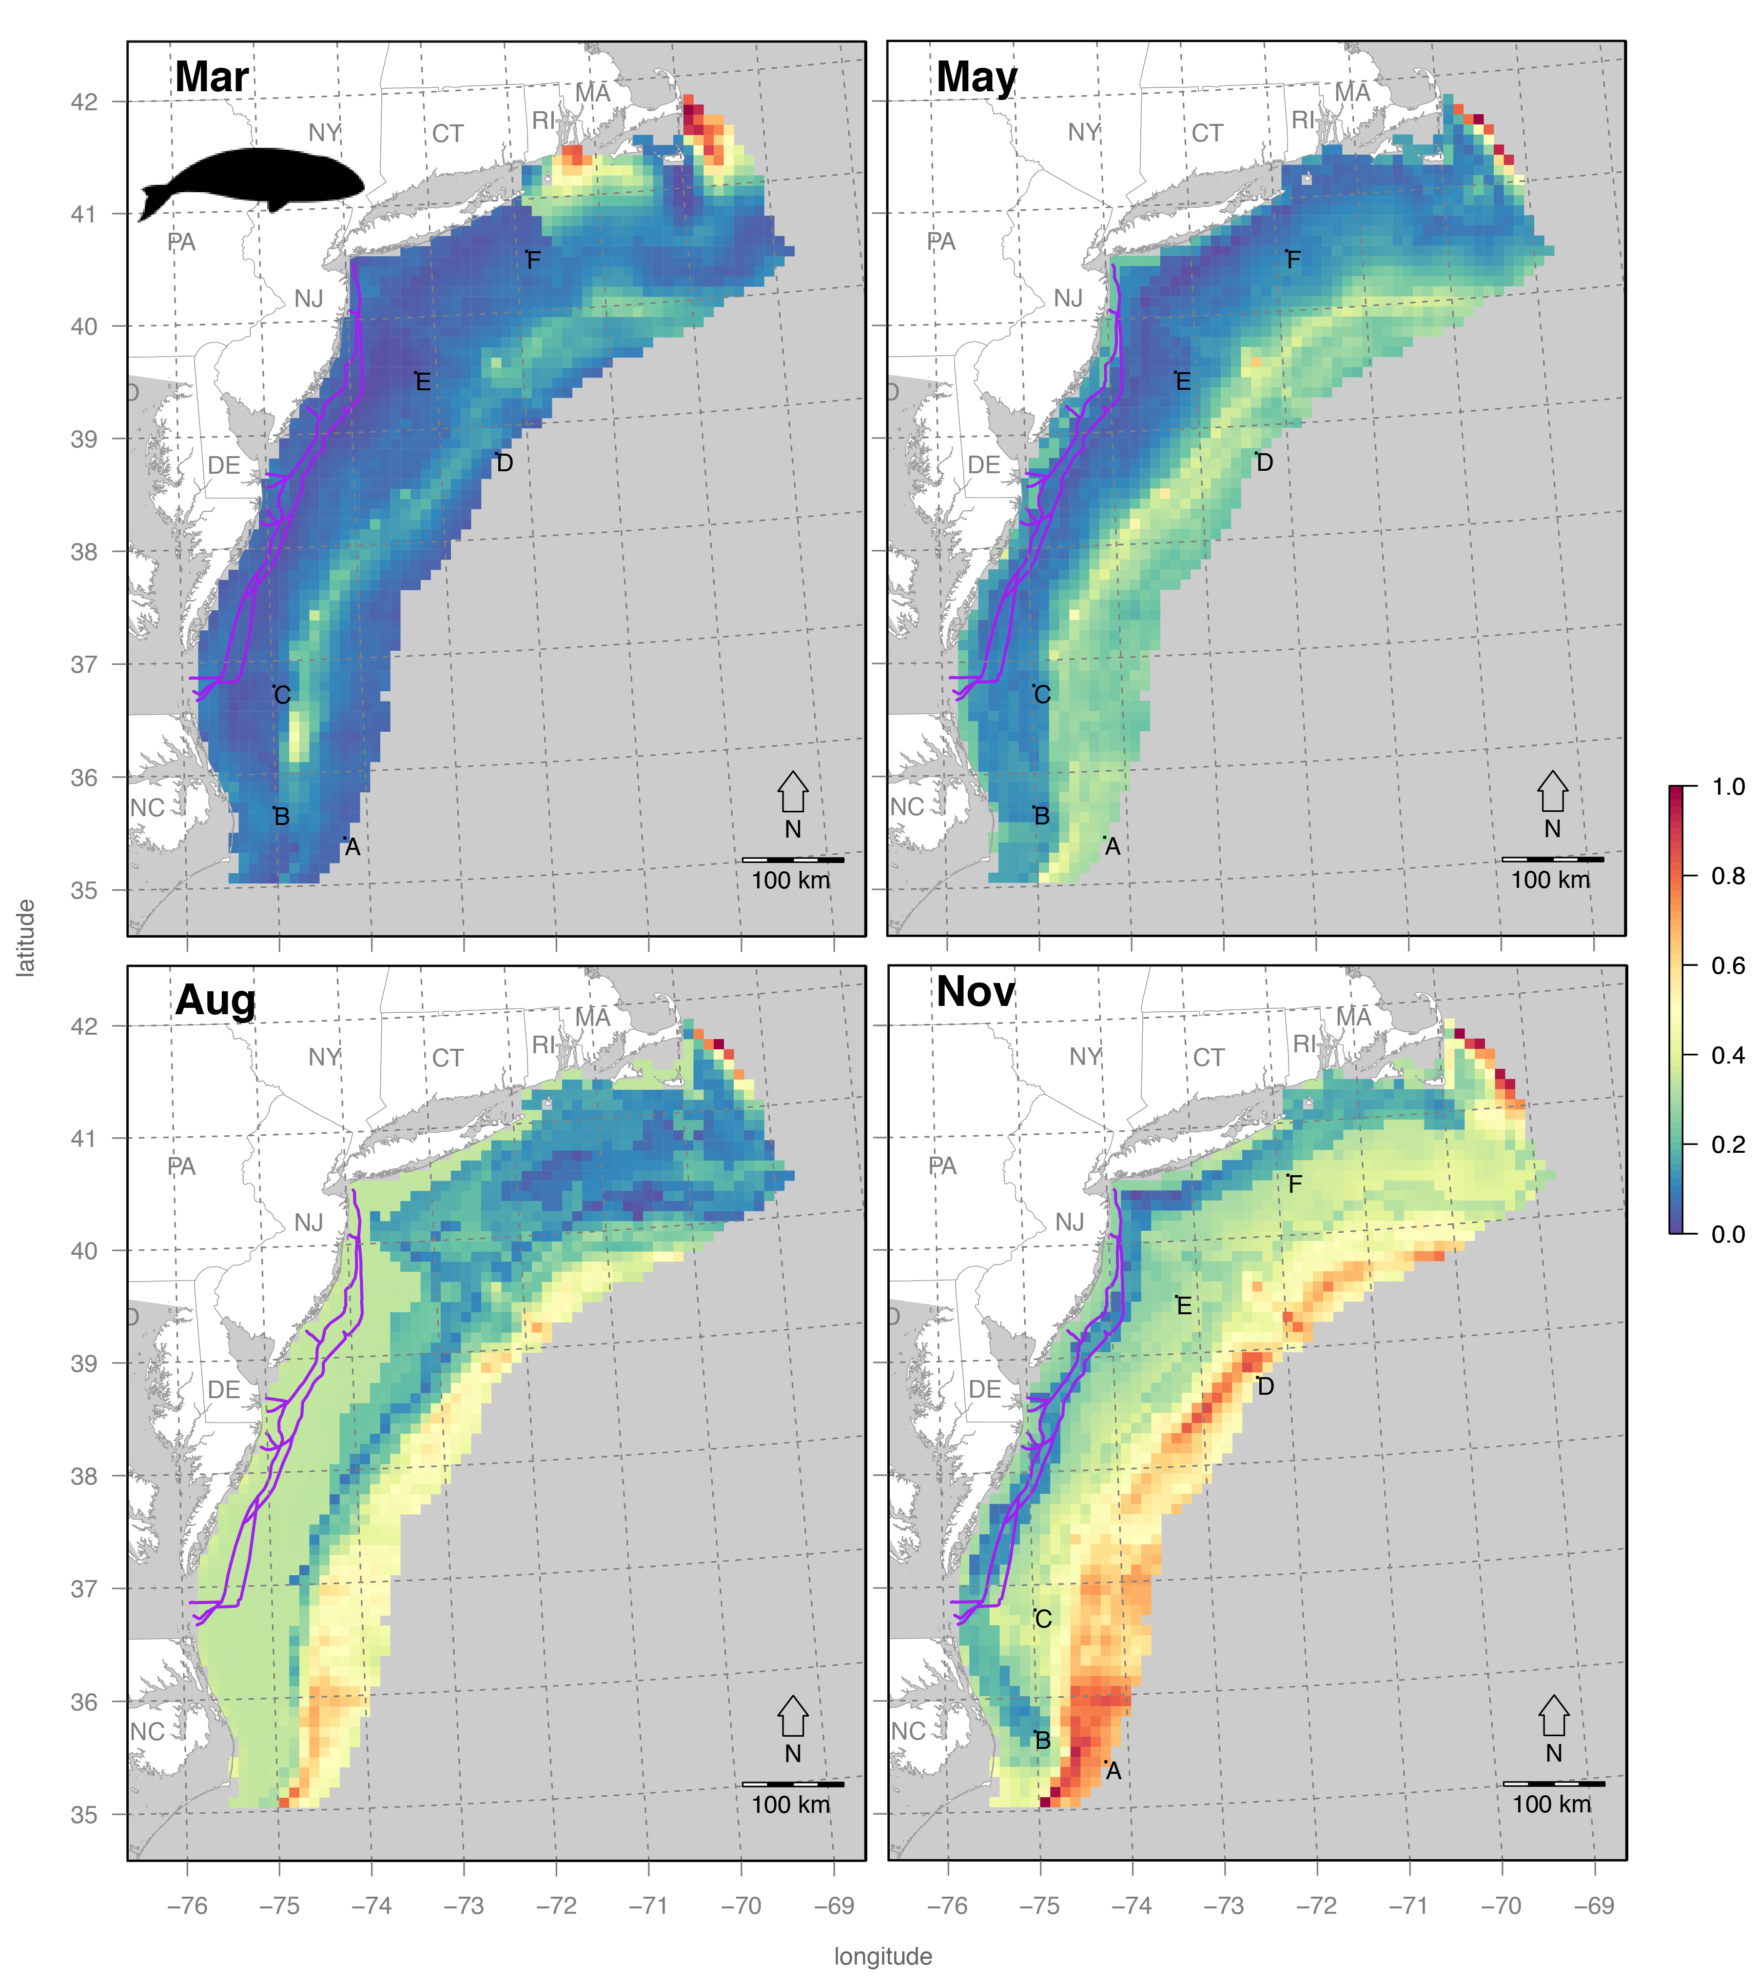

Figure 5. Cetacean Sensitivity for specific months with site labels.

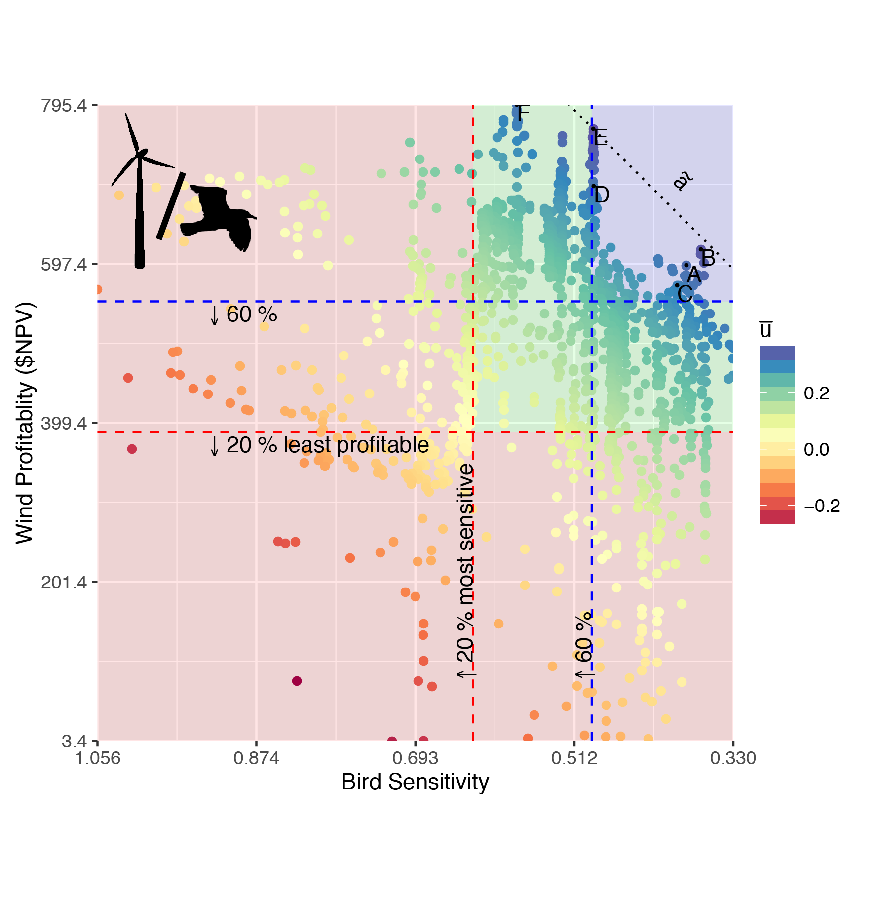

Figure 6. Tradeoff for all sites between bird sensitivity and wind profitability as net present value (NPV) in $US millions. Sites with negative NPV were excluded from this plot. Values were rescaled before calculating average utility ($\overline{u}$) of each site from 11 simulations of the utility function ranging *a* in equation ( 8 ) from 0 to 1. The slope of the median $\tilde{a}$ is shown as a dotted line passing through the highest utility site E. The red quadrant corresponds to the sites with the least 20% of profitability or the most 20% of bird sensitivity. The upper right blue quadrant corresponds with sites excluding the 60% least profitable and 60% most sensitive, hence a preferred subset for development of offshore wind energy.

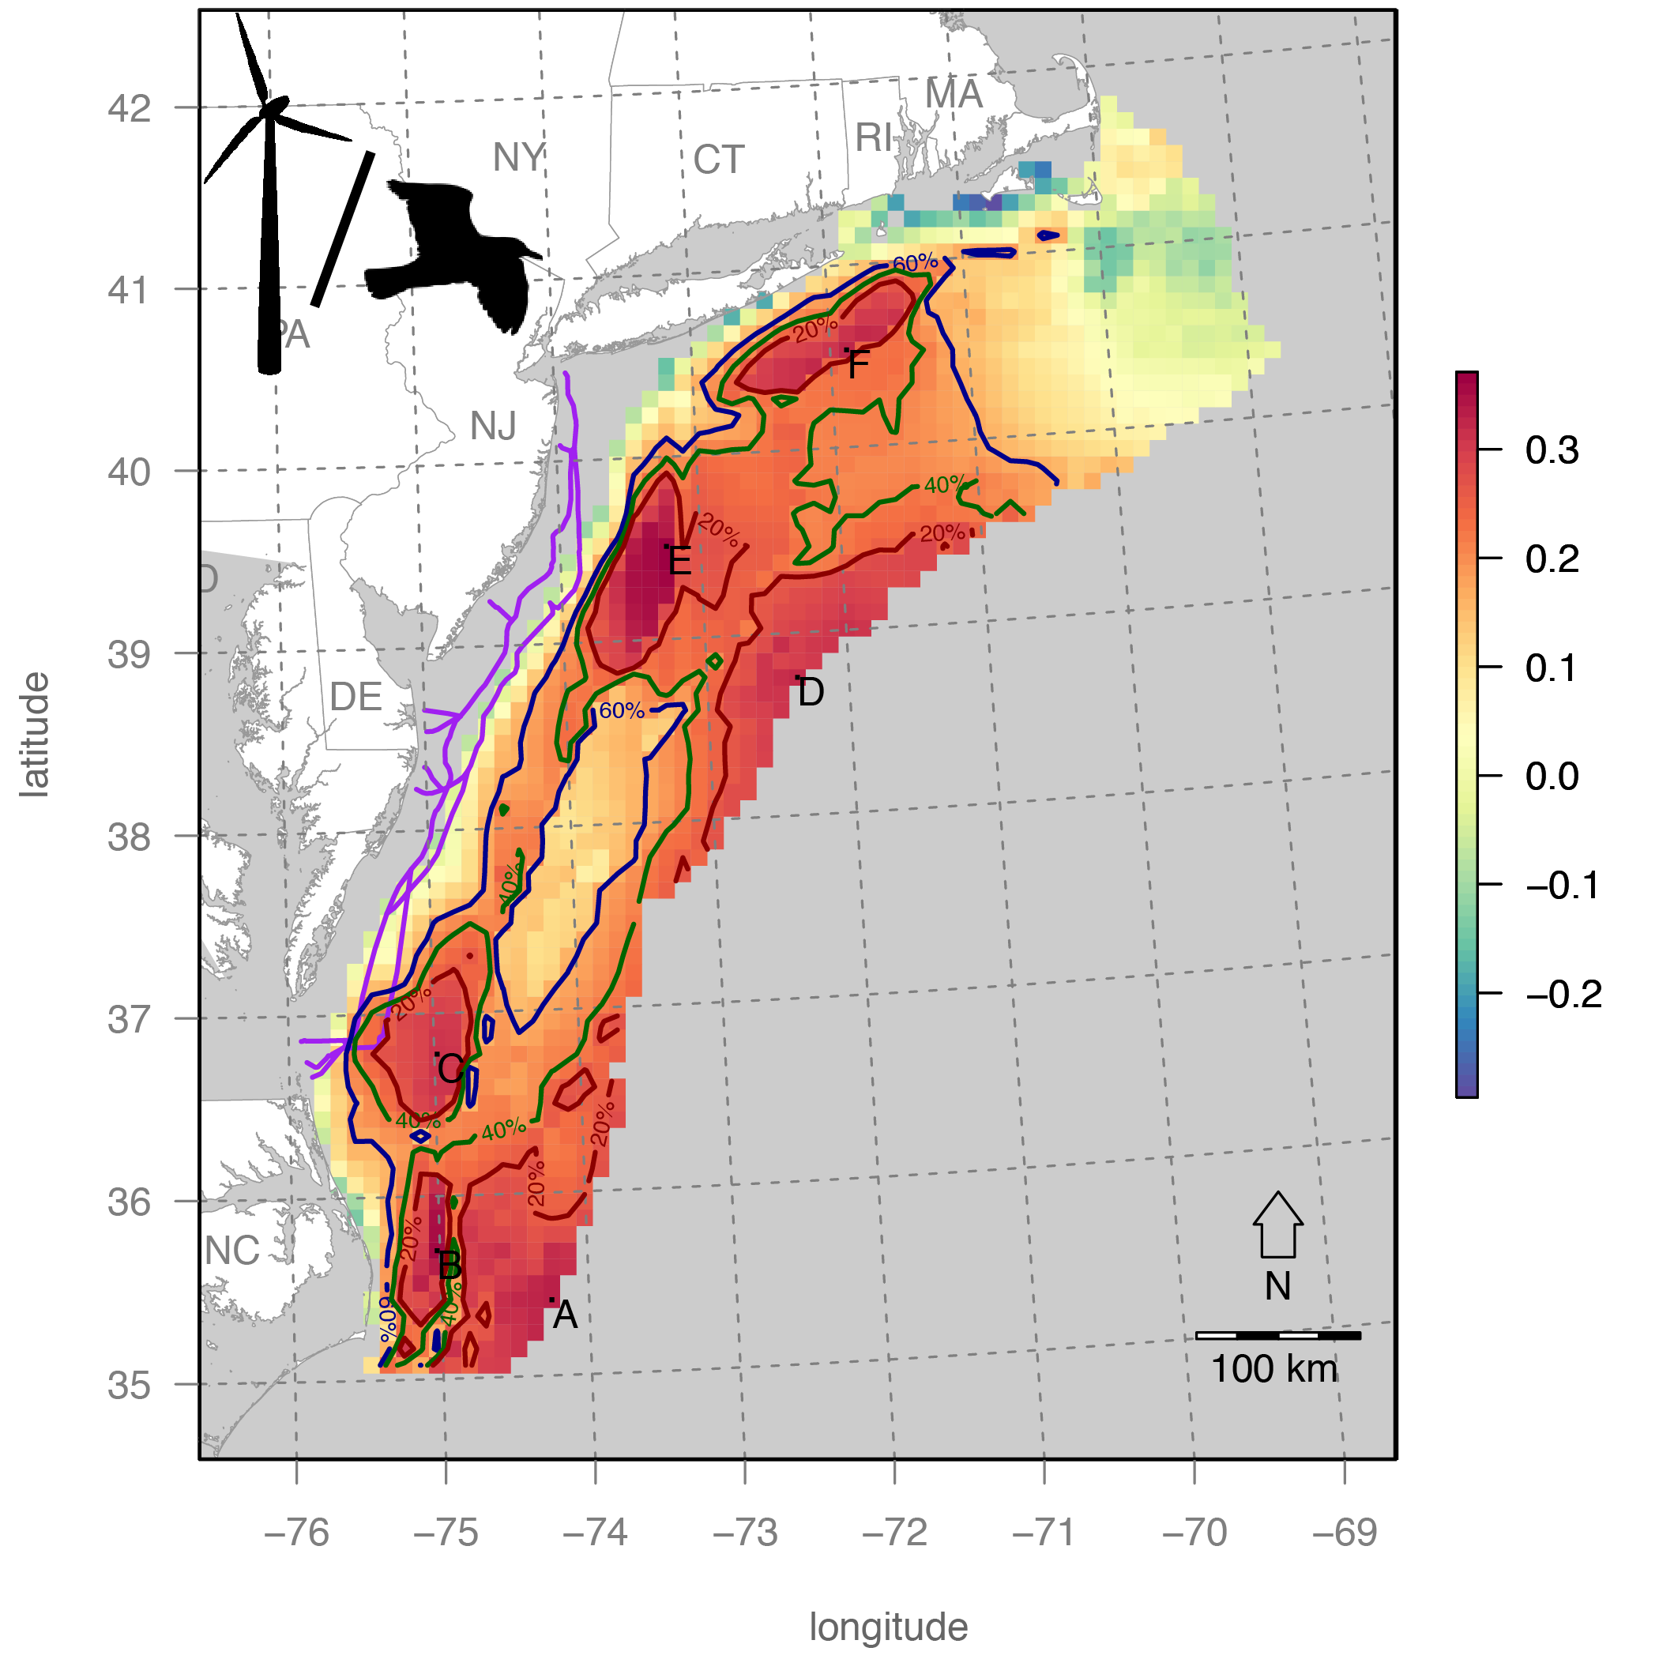

Figure 7. Map of average utility from simulation. Contours for the top 20%, 40% and 60% quantiles of average utility. Site labels A-E are of highest utility within the 20% contour area and correspond with labels in the tradeoff plot (Figure 6) and table of values (Table 4).



Figure 8. Cetacean sensitivity over months of the year for selected sites (also in Figure 6, Figure 7, Figure 8) where lowest values suggest seasonal absence of endangered migratory cetaceans for timing pre-operational OWED activities (such as seismic surveying or pile driving).

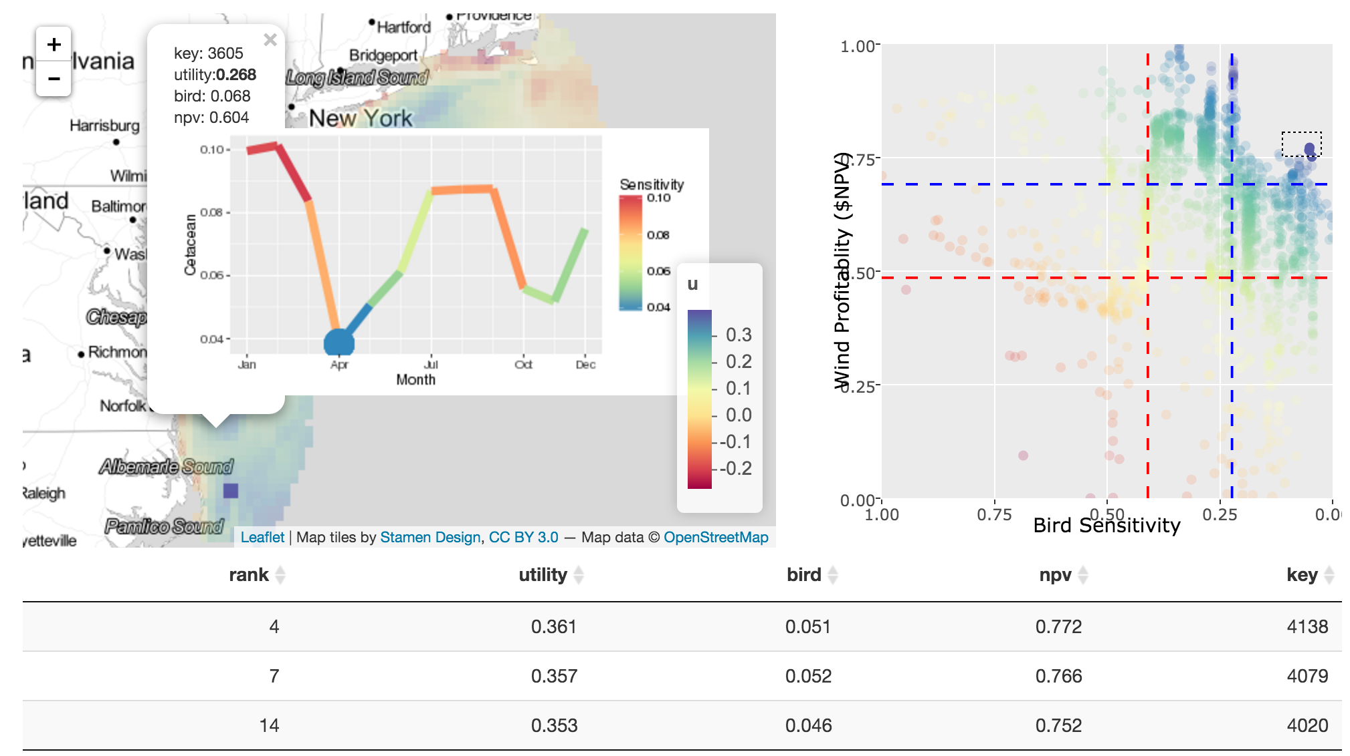

Figure 9. Spatio-temporal decision support interface showing interactive map on the left and tradeoff plot of bird sensitivity versus industry profitability on the right. Clicking on a given pixel in the map will popup cetacean sensitivity over the year to and highlight the month with the minimum sensitivity for timing harmful activities such as pile driving and seismic airgun surveying. Selecting rows in the table will highlight them on the tradeoff plot. Selecting points on the tradeoff plot will highlight them in the map.

Macintosh HD:Users:bbest:github:consmap-prep:img:siting_summary.pdf

Figure 10. Summary cartoon of spatio-temporal tradeoff framework minimizing operational impacts on birds by siting OWED in space and episodic impacts on cetaceans by timing activities.

# Supplement

Table 5: Parameter estimates for modeling transmission Costs.

|  |  |  |
| --- | --- | --- |
|  | **Costs if ≤ 60km (AC)** | **Costs if > 60km (DC)** |
| MW | .81\*\*\* | 1.09\*\* |
|  | -0.15 | -0.37 |
| Cables (km) | 1.36 | 0.89 |
|  | -1.19 | -1.61 |
| Adj R2 | 0.937 | 0.951 |
|  |  |  |

# References

Arkema KK, Abramson SC, Dewsbury BM (2006) Marine ecosystem-based management: from characterization to implementation. Front Ecol Environ 4:525–532

Bailey H (2012) Impacts of wind turbine construction on marine mammals: What can be done? Int Sustain Energy Rev

Bailey H, Brookes KL, Thompson PM (2014) Assessing environmental impacts of offshore wind farms: lessons learned and recommendations for the future. Aquat Biosyst 10:8

Beaudry-Losique J, Boling T, Brown-Saracino J, Gilman P, Hahn M, Hart C, Johnson J, McCluer M, Morton L, Naughton B, others (2011) A national offshore wind strategy: creating an offshore wind energy industry in the United States. US Dep Energy Off Energy Effic Renew Energy Wind Water Power Program US Dep Inter Bur Ocean Energy Manag Regul Enforc

Best B (2016) siting: initial manuscript version.

Bradbury G, Trinder M, Furness B, Banks AN, Caldow RWG, Hume D (2014) Mapping Seabird Sensitivity to Offshore Wind Farms. PLoS ONE 9:e106366

Chang W, Cheng J, Allaire JJ, Xie Y, McPherson J (2016) shiny: Web Application Framework for R.

Chang W, Wickham H (2015) ggvis: Interactive Grammar of Graphics.

Cheng J, Xie Y (2015) leaflet: Create Interactive Web Maps with the JavaScript “Leaflet” Library.

Crowder L, Norse E (2008) Essential ecological insights for marine ecosystem-based management and marine spatial planning. Mar Policy 32:772–778

Damian H-P, Merck T (2014) Cumulative impacts of offshore windfarms. In: Agency FM and H, Safety FM for the E Nature Conservation and Nuclear (eds) Ecological Research at the Offshore Windfarm alpha ventus. Springer Fachmedien Wiesbaden, p 193–198

Douvere F (2008) The importance of marine spatial planning in advancing ecosystem-based sea use management. Mar Policy 32:762–771

Faber-Langendoen D, Master L, Nichols J, Snow K, Tomaino A, Bittman R, Hammerson G, Heidel B, Ramsay L, Young B (2009) NatureServe conservation status assessments: methodology for assigning ranks. NatureServe Arlingt Va

Firestone J, Archer CL, Gardner MP, Madsen JA, Prasad AK, Veron DE (2015) Opinion: The time has come for offshore wind power in the United States. Proc Natl Acad Sci 112:11985–11988

Fleishman E, Costa DP, Harwood J, Kraus S, Moretti D, New LF, Schick RS, Schwarz LK, Simmons SE, Thomas L, Wells RS (2016) Monitoring population-level responses of marine mammals to human activities. Mar Mammal Sci:n/a–n/a

Furness RW, Wade HM, Masden EA (2013) Assessing vulnerability of marine bird populations to offshore wind farms. J Environ Manage 119:56–66

Garthe S, Hüppop O (2004) Scaling possible adverse effects of marine wind farms on seabirds: developing and applying a vulnerability index. J Appl Ecol 41:724–734

Goodale MW, Milman A (2016) Cumulative adverse effects of offshore wind energy development on wildlife. J Environ Plan Manag 0:1–21

Gopnik M (2013) What Regional Ocean Planners Can Learn from the U.S. Public Lands Management. Sea Grant Law Policy J 6:46

Guerry AD, Ruckelshaus MH, Arkema KK, Bernhardt JR, Guannel G, Kim C-K, Marsik M, Papenfus M, Toft JE, Verutes G, Wood SA, Beck M, Chan F, Chan KMA, Gelfenbaum G, Gold BD, Halpern BS, Labiosa WB, Lester SE, Levin PS, McField M, Pinsky ML, Plummer M, Polasky S, Ruggiero P, Sutherland DA, Tallis H, Day A, Spencer J (2012) Modeling benefits from nature: using ecosystem services to inform coastal and marine spatial planning. Int J Biodivers Sci Ecosyst Serv Manag:1–15

Harwood J, King S, Booth C, Donovan C, Schick RS, Thomas L, New L (2016) Understanding the Population Consequences of Acoustic Disturbance for Marine Mammals. In: Popper AN, Hawkins A (eds) The Effects of Noise on Aquatic Life II. Springer New York, p 417–423

Hastie GD, Russell DJ, McConnell B, Moss S, Thompson D, Janik VM (2015) Sound exposure in harbour seals during the installation of an offshore wind farm: predictions of auditory damage. J Appl Ecol 52:631–640

Kinlan BP, Zipkin EF, O’Connell AF, Caldow C (2012) Statistical analyses to support guidelines for marine avian sampling: final report. US Department of the Interior, Bureau of Ocean Energy Management, Office of Renewable Energy Programs, Herndon, VA. OCS Study BOEM 2012-101. NOAA Tech Memo NOS NCCOS 158

Lester SE, Costello C, Halpern BS, Gaines SD, White C, Barth JA (2013) Evaluating tradeoffs among ecosystem services to inform marine spatial planning. Mar Policy 38:80–89

O’Connell A, Spiegel CS, Johnson S (2011) Compendium of Avian Occurrence Information for the Continental Shelf Waters along the Atlantic Coast of the United States, Final Report (Database Section-Shorebirds). Prepared by the US Fish and Wildlife Service, Hadley, MD for the USGS Patuxent Wildlife Research Center, Beltsville, MD. US Department of the Interior, Geological Survey, and Bureau of Ocean Energy Management Headquarters, OCS Study BOEM 2012-076. i

Osmond M, Airame S, Caldwell M, Day J (2010) Lessons for marine conservation planning: A comparison of three marine protected area planning processes. Ocean Coast Manag 53:41–51

Pikitch EK, Santora C, Babcock EA, Bakun A, Bonfil R, Conover DO, Dayton P, Doukakis P, Fluharty D, Heneman B, Houde ED, Link J, Livingston PA, Mangel M, McAllister MK, Pope J, Sainsbury KJ (2004) Ecosystem-Based Fishery Management. Science 305:346–347

Pollnac R, Christie P, Cinner JE, Dalton T, Daw TM, Forrester GE, Graham NAJ, McClanahan TR (2010) Marine reserves as linked social–ecological systems. Proc Natl Acad Sci 107:18262 –18265

R Core Team (2015) R: A Language and Environment for Statistical Computing. R Foundation for Statistical Computing, Vienna, Austria

Roberts JJ, Best BD, Mannocci L, Fujioka E, Halpin PN, Palka DL, Garrison LP, Mullin KD, Cole TVN, Khan CB, McLellan WA, Pabst DA, Lockhart GG (2016) Habitat-based cetacean density models for the U.S. Atlantic and Gulf of Mexico. Sci Rep 6:22615

Saarman E, Gleason M, Ugoretz J, Airamé S, Carr M, Fox E, Frimodig A, Mason T, Vasques J (2013) The role of science in supporting marine protected area network planning and design in California. Ocean Coast Manag 74:45–56

Sharp R, Tallis HT, Ricketts T, Guerry AD, Wood SA, Chaplin-Kramer R, Nelson E, Ennaanay D, Wolny S, Olwero N, others (2015) InVEST User’s Guide, InVEST 3.2. The Natural Capital Project, Stanford University, University of Minnesota, The Nature Conservancy, and World Wildlife Fund

Sievert C, Parmer C, Hocking T, Chamberlain S, Ram K, Corvellec M, Despouy P (2016) plotly: Create Interactive Web Graphics via “plotly.js.”

Slocombe DS (1993) Implementing Ecosystem-Based Management. BioScience 43:612–622

Smith A, Stehly T, Musial W (2015) 2014-2015 Offshore Wind Technologies Market Report.

Thompson PM, Hastie GD, Nedwell J, Barham R, Brookes KL, Cordes LS, Bailey H, McLean N (2013) Framework for assessing impacts of pile-driving noise from offshore wind farm construction on a harbour seal population. Environ Impact Assess Rev 43:73–85

White C, Halpern BS, Kappel CV (2012) Ecosystem service tradeoff analysis reveals the value of marine spatial planning for multiple ocean uses. Proc Natl Acad Sci U S A 109:4696–4701

Winiarski KJ, Miller DL, Paton PWC, McWilliams SR (2014) A spatial conservation prioritization approach for protecting marine birds given proposed offshore wind energy development. Biol Conserv 169:79–88

1. [bdbest@gmail.com](mailto:bdbest@gmail.com) EcoDataScience.com, Santa Barbara, CA [↑](#footnote-ref-1)
2. Marine Geospatial Ecology Laboratory, Nicholas School of the Environment, Duke University, Durham, NC [↑](#footnote-ref-2)
3. For more details on the power curve wind estimation, see the InVEST documentation at <http://data.naturalcapitalproject.org/nightly-build/invest-users-guide/html/wind_energy.html>. [↑](#footnote-ref-3)